A Project on

# SPORTS CLOTHING RETAIL MANAGEMENT SYSTEM

Submitted for Infosys Campus Connect Program

By:

***Shubh Saxena***

***Shiwang Agarwal***

***Shivam Chauhan***

***Shivangi Gupta***

***Shreya Jain***

Under the Guidance of

**Mr. Deepak Rai Sir**



# AJAY KUMAR GARG ENGINEERING COLLEGE, GHAZIABAD

Year : 2017-2018

## **DECLARATION**

We hereby declare that the mini project work entitled “SPORTS CLOTHING RETAIL MANAGEMENT SYSTEM” submitted to the Department of Computer Science and Engineering , Ajay Kumar Garg Engineering College, Ghaziabad is record of an original work done by us under the guidance of “Mr. Deepak Rai”, Department of Information Technology, Ajay Kumar Garg Engineering College, Ghaziabad and this project work is submitted as a part of partial fulfillment of award of Infosys CCP certificate .

Name and Signature of Students:

1. Shubh Saxena

1602710032

1. Shiwang Agarwal

1502710154

1. Shivam Chauhan

1502710145

1. Shivangi Gupta

1502710151

1. Shreya Jain
2. 1502710159

Date: 14/04/2018

Place: Ghaziabad (U.P)

i



## AJAY KUMAR GARG ENGINEERING COLLEGE, GHAZIABAD

**CERTIFICATE**

Certified that “*Shubh Saxena,Shiwang Agarwal,Shivam Chauhan,Shivangi Gupta and Shreya Jain*” have carried out the project work entitled “**SPORTS CLOTHING RETAIL MANAGEMENTSYSTEM**” for the award of **Infosys CCP Certificate** from Ajay Kumar Garg Engineering College, Ghaziabad under my supervision.

To the best of my knowledge, this work has not been submitted earlier to any university for the award of any degree.

***Mr. Deepak Rai***

***Assistant Professor , Department of Computer Science and Engineering***

**ABSTRACT**

This project “Sports Clothing Retail Management System” a web based project –

specialized as E-Store - it is aimed to analyze the varying point of views : customer,

company, vendor etc. The structure of this project is being handled at this document.

Providing instant shipment shopping to customers without waiting days or hours. Minutes can be enough for products to be handled. Also creating profiles, showing up clothes obtains increased advertisement, having fun, creating own fashion, seeing who wear what. This estore project will be innovative looking to old e-store picture.

Using the great influence of the internet on human beings the product is prepared in order to improve the shopping opportunities of the potential customers. This product will take a bridging role between customers, companies and vendors, and make them bound on the online platform.

### **TABLE OF CONTENTS**

Chapters

#### Chapter I: Introduction………………………………………………………………………………...**1**

1.1Purpose

1.2Scope

1.3Overview

#### Chapter II: Requirement Analysis…………………………………………………………………….**2-4**

2.1Requirement Analysis

2.1.1Functional Requirements

2.1.2Non Functional Requirements

2.1.2.1Usability Requirements

2.1.2.2Security Requirements

#### Chapter III: System Analysis and Design……………………………………………………………..4

3.1Analysis

3.2System Design

3.2.1 Use Case Diagram……………….…………………………………………………………….5

3.2.2 E-RDiagram…………………………………………………………………..6

3.2.3 Data Flow Diagram…………………………………………………………………………..7-8

#### Chapter IV: Testing……………………………………………………………………………………...**9**

4.1System Testing

4.2Testing Conclusion

#### Chapter V: Advantages and Limitations of Developed System………………………………………10

5.1 Advantage of DevelopedSystem 5.2Limitations of Developed System

#### Chapter VI: Conclusions and Suggestions for further work…………………………………………..10

6.1Conclusion

6.2Suggestions for further work

**Chapter VII:**

Snapshots………………………………………………………………………………….…11-17

Code snippet …………………………………………………………………………………………18-33

**Appendix:**

**Bibliography………………………………………………………………………**…………………...….33

#### 1**.Introduction**

**Purpose**

In a web Based project - specialized as E-Store - it is aimed to analyze the varying point of views : customer, company, vendor etc. The structure of this project is being handled at this document*.*

## **1.1.1 Initial Vision**

Providing instant shipment shopping to customers without waiting days or hours. Minutes can be enough for products to be handled. Also creating profiles, showing up clothes obtains increased advertisement, having fun, creating own fashion, seeing who wear what. This estore project will be innovative looking to old e-store picture.

**1.2Scope**

Using the great influence of the internet on human beings the product is prepared in order to improve the shopping opportunities of the potential customers. This product will take a bridging role between customers, companies and vendors, and make them bound on the online platform.

##### **1.3Overview**

The sports clothing retail system provides the facility to purchase the sports products. Any person can search for the particular product which he desire forand the prize of that product is available along with it .On the other hand, the system calculates the total amount of the selected products that is purchased by the customer. So this management system proves to be useful for customers as it provides the detailed description of the available sports items.

#### 2.**Requirement Analysis and Feasibility study**

##### **2.1Requirement analysis**

Under these head we will discuss about functional and non-functional requirements of the web application.

**2.1.1Functional requirements**

User

register

#### **verify** polymorphism

verify(Company) **polymorphism**

verify(Vendor) **polymorphism**

login(User,Pass)

Customer inheritance **(USER)**

update Profile

select Product

order

type Destination

select Payment Type

rate

comment

add Address

view Orders

select Address

select Order

rebate

update Address

Customer Address

get part

group Customers

#### **Vendor** inheritance (USER)

pick in stock product

feedback

get sales report

receive order

get rebate report

approve Vendor

Vendor In Stock Product

alert out of Stock

get Amount set Amount

increase Amount

decrease Amount

#### **Company** inheritance (USER)

upload Product update Product

get Report

get Rebate Report

Product

check in Sale

get Product

announce Sale Product

sale Product( amount, percentage )

City State Part

show City

show States

show Parts

Order

alert Rebate

check Rebate Time

add Order Product

approve Purchase

#### **get Order Count by Company** *variations can also includes payment reports

#### **get Order Count by Vendor** *variations can also includes payment reports

Payment

add To Commission

Commission

get Monthly Profit report

get Annual Profit report

get Profit

2

###### **2.1.2Non-functional requirements**

**2.1.2.1Usability requirements**

The website must be user-friendly so that the user is easy to learn when they first get into the website. It also must have the clear instructions so that the user will be guided when using the website**.**

**2.1.2.2Security Requirements**

This system is highly secure in the login part. It can know the authorization of a ID which belongs member or admin . No any person can book any ticket or cancel any booked ticket without login into the system with proper userid and password . The admin module is also secured with layer of authentication by userid and password .

1. **System Analysis and Design :**

**3.1.Analysis :**

On analyzing the system we find that the system is mainly divided into two main modules They are :

* **Admin Module**
* **Customer Module**

**3.2.System Design :**

The design of the system can be easily understood by following diagrams :

* + 1. Use Case Diagram
    2. ER Diagram
    3. Data Flow Diagram

**Use Case Diagram**

A **use case diagram** at its simplest is a representation of a user's interaction with the system that shows the relationship between the user and the different [use cases](https://en.wikipedia.org/wiki/Use_case) in which the user is involved. A use case diagram can identify the different types of users of a system and the different use cases and will often be accompanied by other types of diagrams as well.

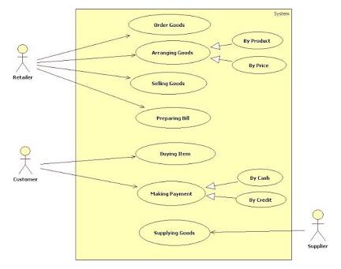

**ER Diagram**

An **Entity–relationship model** (**ER model** for short) describes interrelated things of interest in a specific domain of knowledge. A basic ER model is composed of entity types (which classify the things of interest) and specifies relationships that can exist between instances of those entity types.

An entity–relationship diagram for an [MMORPG](https://en.wikipedia.org/wiki/MMORPG) using Chen's notation.

In [software engineering](https://en.wikipedia.org/wiki/Software_engineering), an ER model is commonly formed to represent things that a business needs to remember in order to perform business processes. Consequently, the ER model becomes an abstract [data model](https://en.wikipedia.org/wiki/Data_modeling), that defines a data or information structure which can be implemented in a [database](https://en.wikipedia.org/wiki/Database), typically a [relational database](https://en.wikipedia.org/wiki/Relational_database).

Entity–relationship modeling was developed for database design by [Peter Chen](https://en.wikipedia.org/wiki/Peter_Chen) and published in a 1976 paper.[[1]](https://en.wikipedia.org/wiki/Entity%E2%80%93relationship_model#cite_note-Chen-1) However, variants of the idea existed previously.[[2]](https://en.wikipedia.org/wiki/Entity%E2%80%93relationship_model#cite_note-2) Some ER models show super and subtype entities connected by generalization-specialization relationships,[[3]](https://en.wikipedia.org/wiki/Entity%E2%80%93relationship_model#cite_note-3) and an ER model can be used also in the specification of domain-specific [ontologies](https://en.wikipedia.org/wiki/Ontology_(computer_science)).

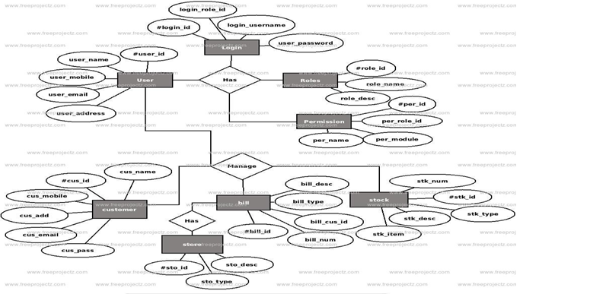

**Data flow diagram**

**Data flow diagram** (**DFD**) is a graphical representation of the "flow" of data through an [information system](https://en.wikipedia.org/wiki/Information_system), modelling its *process* aspects. A DFD is often used as a preliminary step to create an overview of the system without going into great detail, which can later be elaborated.[[2]](https://en.wikipedia.org/wiki/Data_flow_diagram#cite_note-2) DFDs can also be used for the [visualization](https://en.wikipedia.org/wiki/Data_visualization) of [data processing](https://en.wikipedia.org/wiki/Data_processing)(structured design).

A DFD shows what kind of information will be input to and output from the system, how the data will advance through the system, and where the data will be stored. It does not show information about process timing or whether processes will operate in sequence or in parallel, unlike a traditional structured [flowchart](https://en.wikipedia.org/wiki/Flowchart) which focuses on control flow, or a UML activity workflow diagram, which presents both control and data flows as a unified model.[[*citation needed*](https://en.wikipedia.org/wiki/Wikipedia:Citation_needed)]

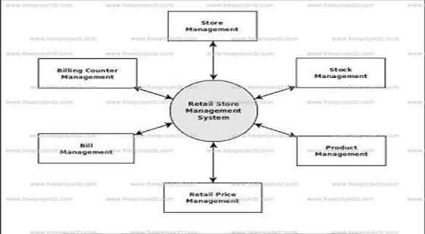

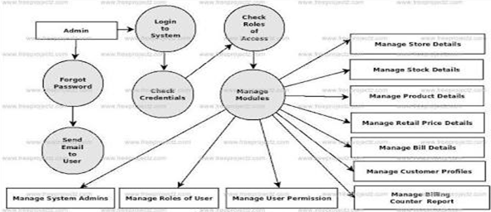

#### **4.Testing**

##### **4.1System Testing**

Is the menu bar displayed in the appropriate location of the screen and with system related feature ? Do pull-down menu operation and tool bars work properly. Are all menu functions and pull down sub functions properly listed. The purpose of system testing is to consider all the likely variations to which It will be suggested and push the system to limits. The testing focusses on the logical intervals of the software ensuring that all statements have been tested and on

functional interval is conducting tests to uncover errors and ensures that defined input

will produce results that agree with the required results. Program level testing modules level

testing integrated and carried out.

There are of two testing.

Those are :

1. White Box Testing
2. Black Box Testing

**White Box Testing –** White box sometimes called “Glass Box Testing” is a test case design uses The control structure of the procedural design to drive test case .

**Black Box Testing** – Black Box Testing focusses on functional requirements of the software

**4.2Testing Conclusion :**

After performing all the tests on the system developed it can be concluded that this system

will prove to be powerful package in satisfying all the requirements of the given system . The system is able to perform its basic operations within a allotted time frame and can handle multiple users at a time .

9

#### **5.Advantages and limitations of the Developed system**

##### 5.1Advantages of Developed System

* System responses fast enough when user performs some action
* Interface is user friendly and easy to use
* Allow user to update their profile
* Allow user to search Products
* Allow user to select the desired product

5.2Limitations of the Developed System

* The website does not support older versions of web browsers such as IE6.
* Will have to use external application such as excel to generate report.
* User must be registered before booking a ticket.

#### **6.Conclusion and Suggestion for further work**

**6.1Conclusion :**

Our project is only a humble venture to satisfy the needs of retail system. Several user friendly coding have been adopted. This package will prove to be powerful package in satisfying all the requirements of the organization.

**6.2Suggestion for Further work :**

In the future there are few things that might improve. First is to enhance the browser compatibility. Users may use different platform and also different browser to visit the website. Second , there may be much more functions which may be included in the future. Third, user may be notified via SMS for each of his/her activity.

**Snapshot**

**:**

**1**

**.**

**Index**

**Page**

**:**

**2**

**.**

**Registration**

**Page**

**:**

11

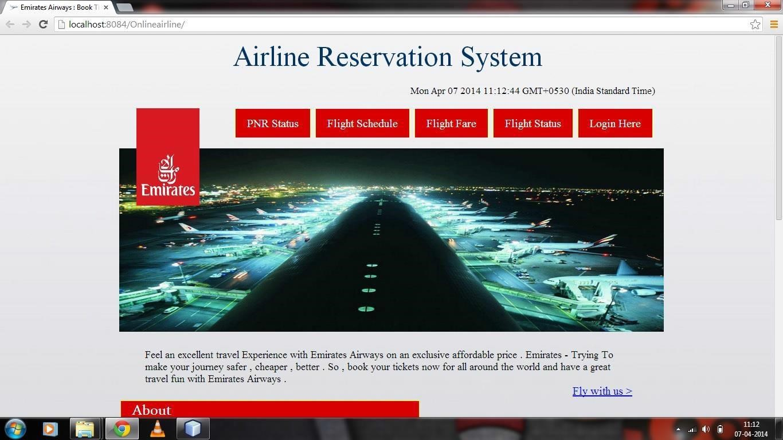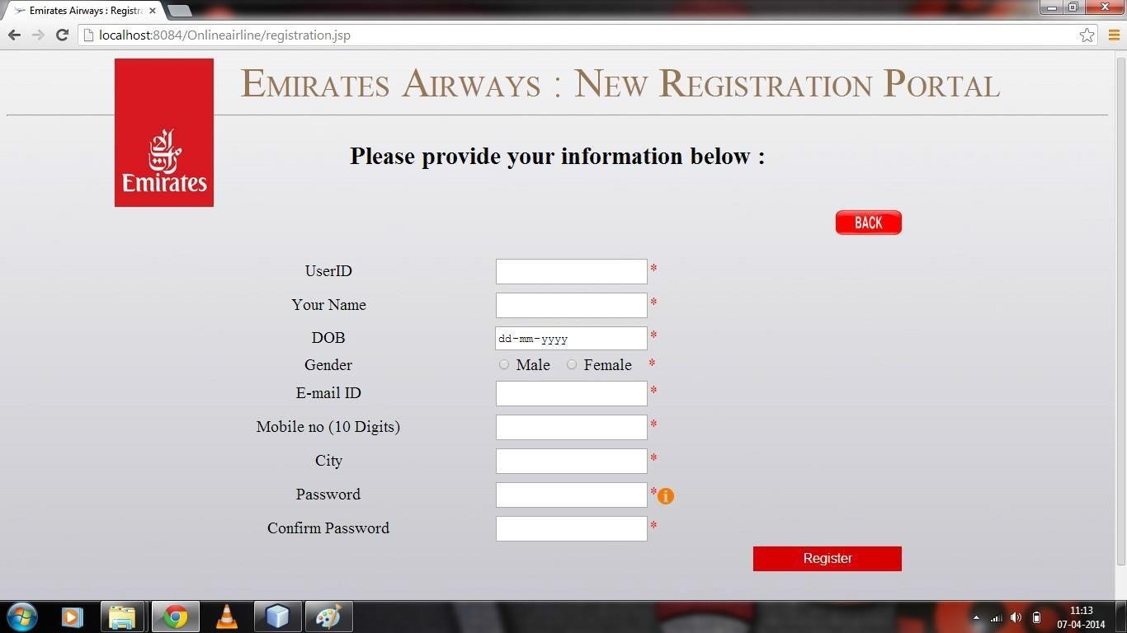

**3.**

**Login**

**Page**

**:**

**4.**

**Customer**

**Page**

**:**

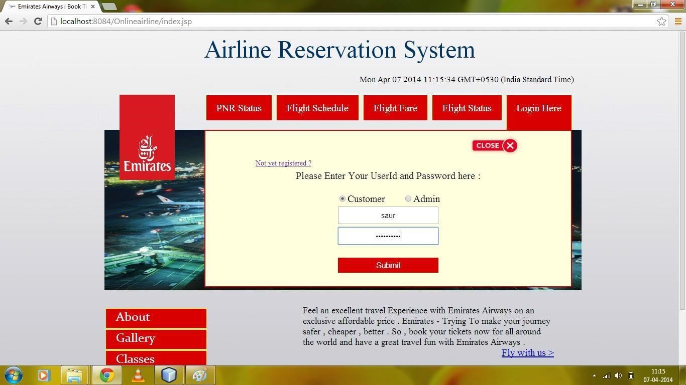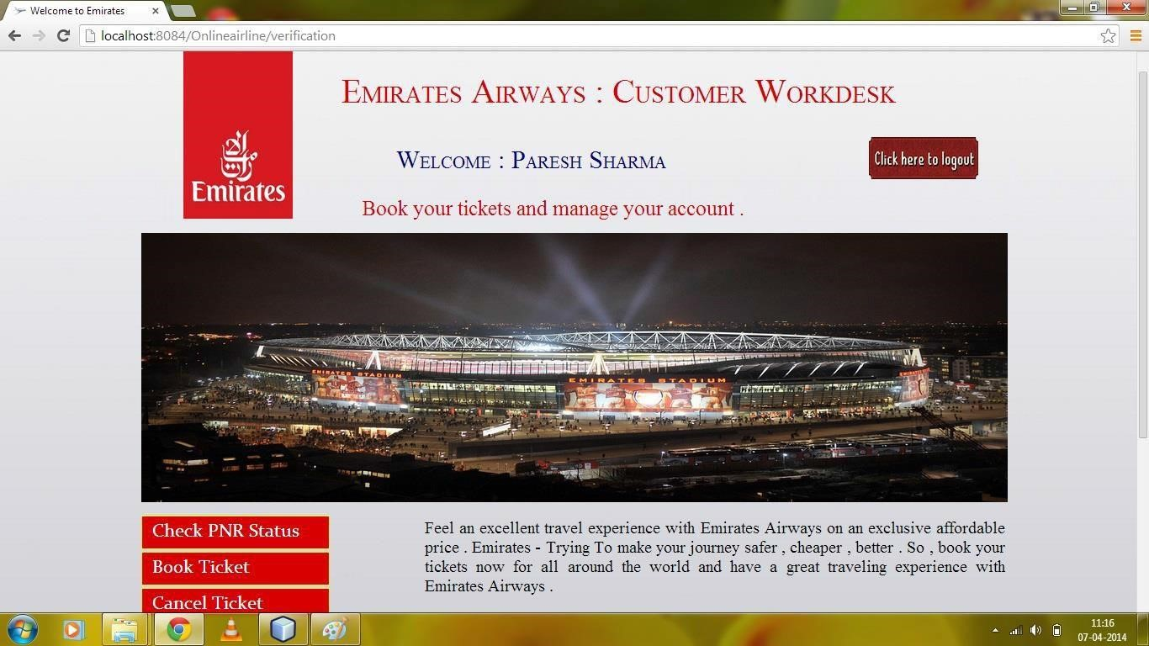

**5.**

**Book**

**Flights**

**:**

6.

**Availability :**

13

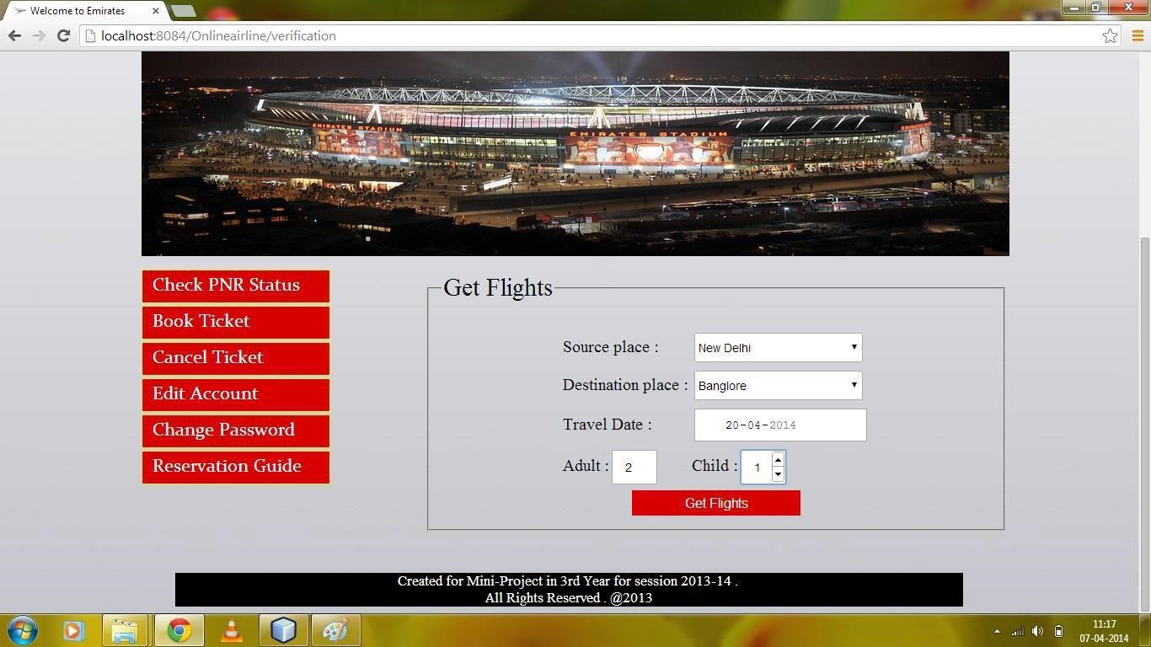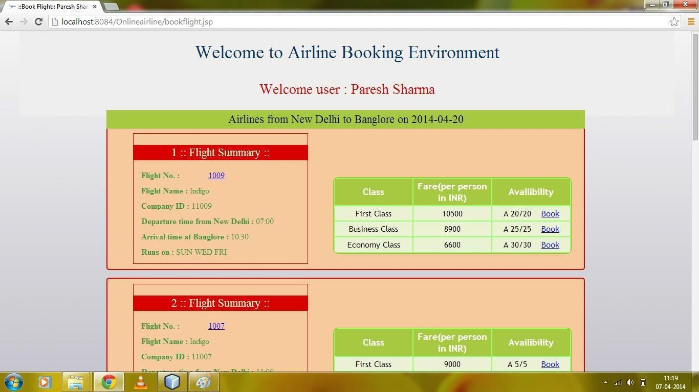

**7.**

**Book**

**Details**

**:**

**8.**

**PNR**

**Status**

**:**

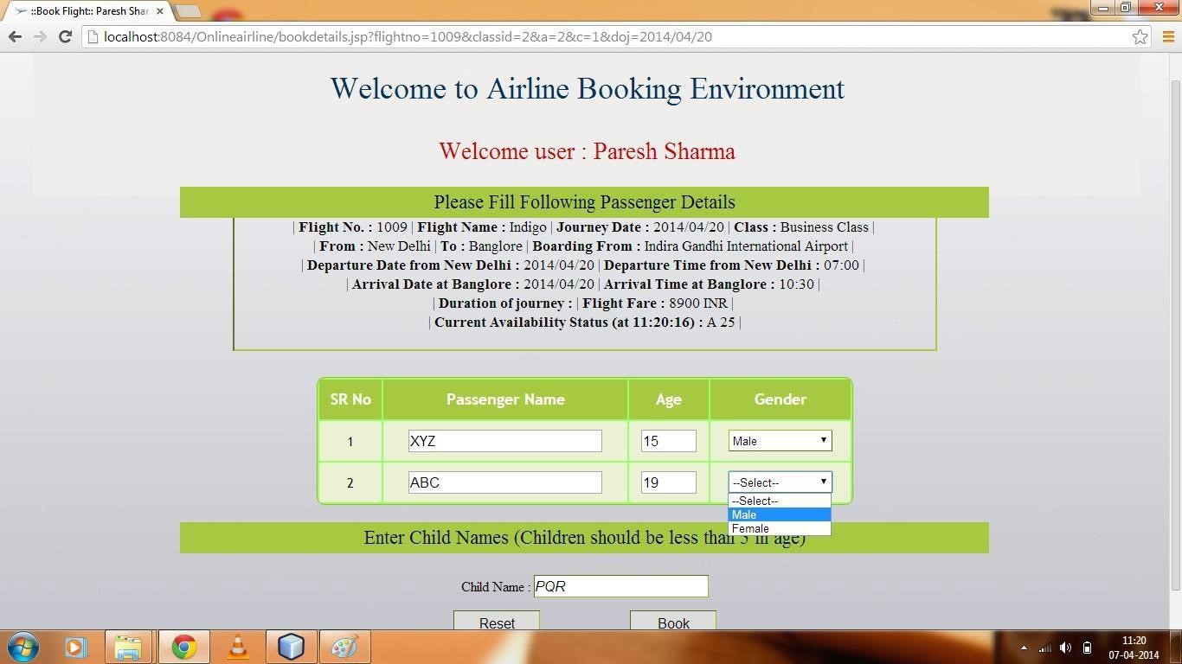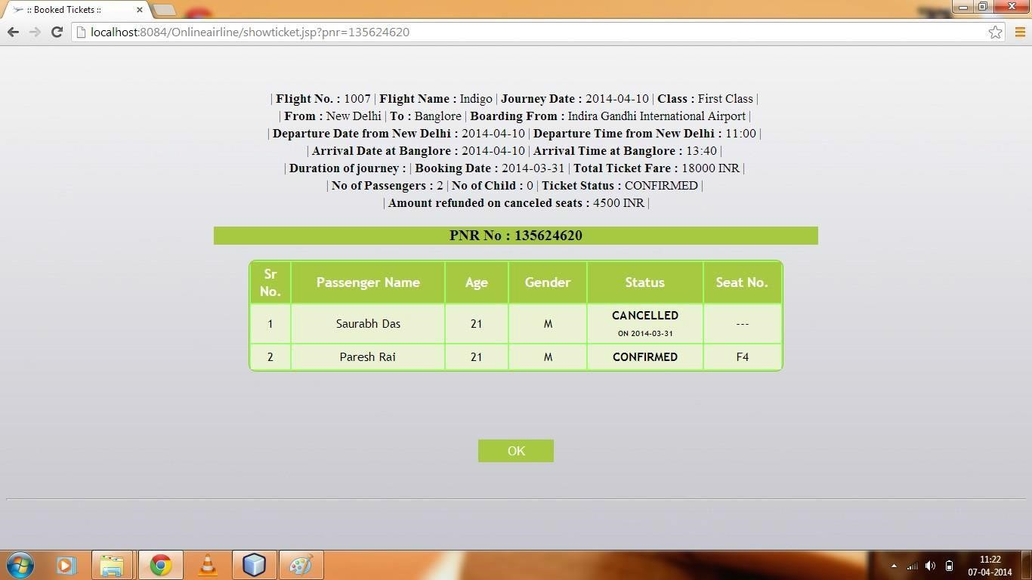

**9.**

**Edit**

**Customer**

**Profile**

**:**

**10.**

**Add**

**new flight**

**:**

15

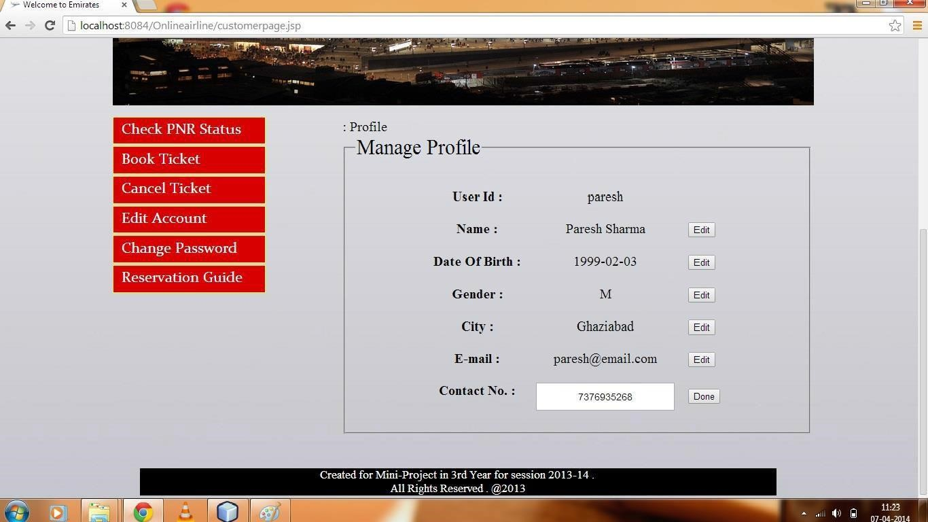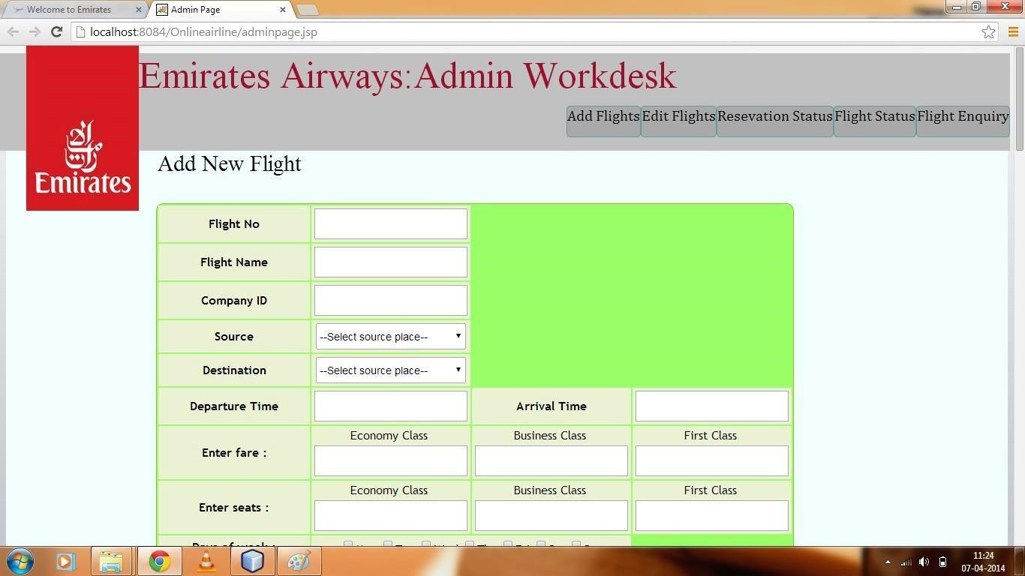

**11.**

**Cancel/Reschedule**

**Flight**

**:**

**12.**

**Edit**

**Flight**

**:**

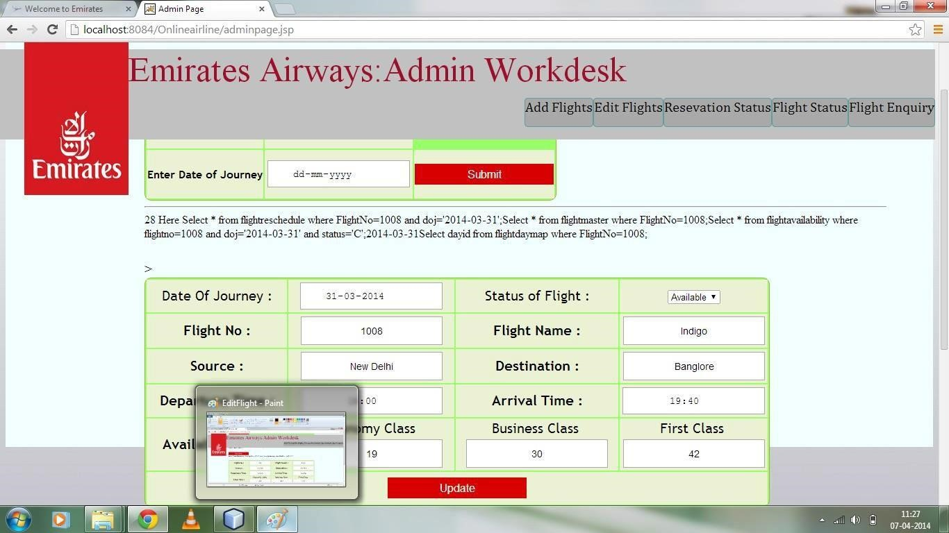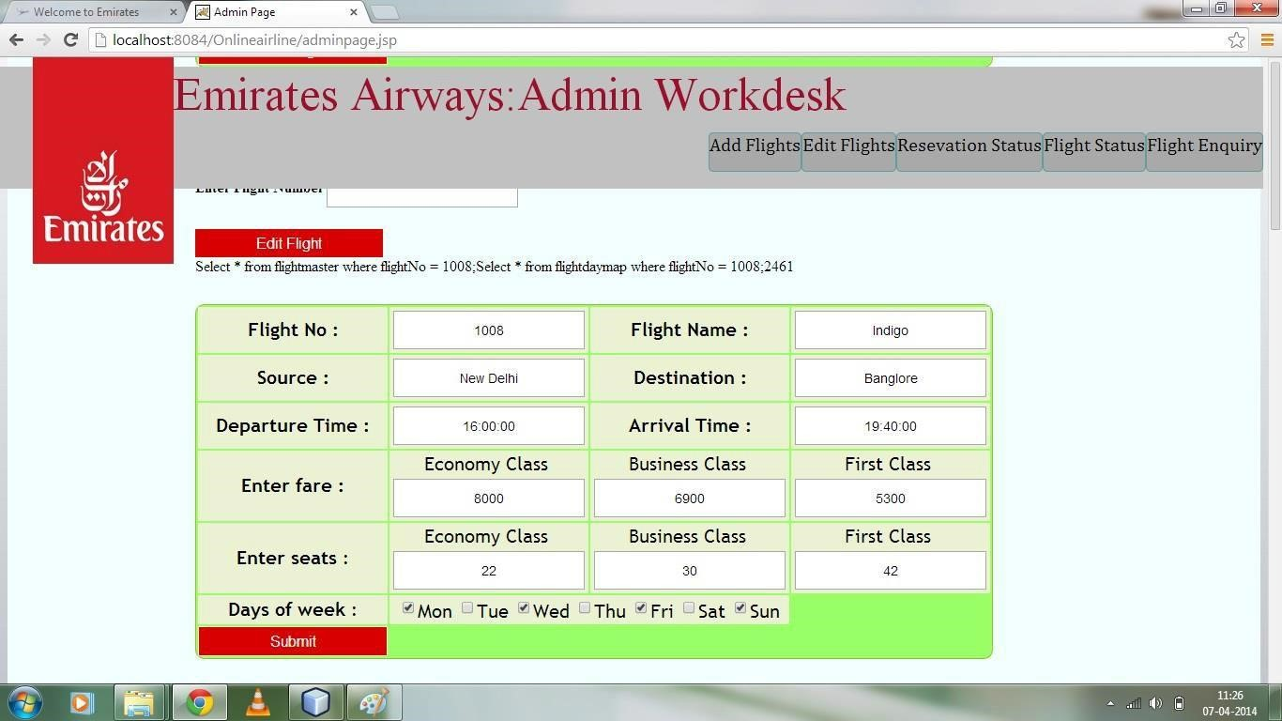

**13.**

**Flight**

**Status**

**:**

**14.**

**Report**

**Generation**

**:**

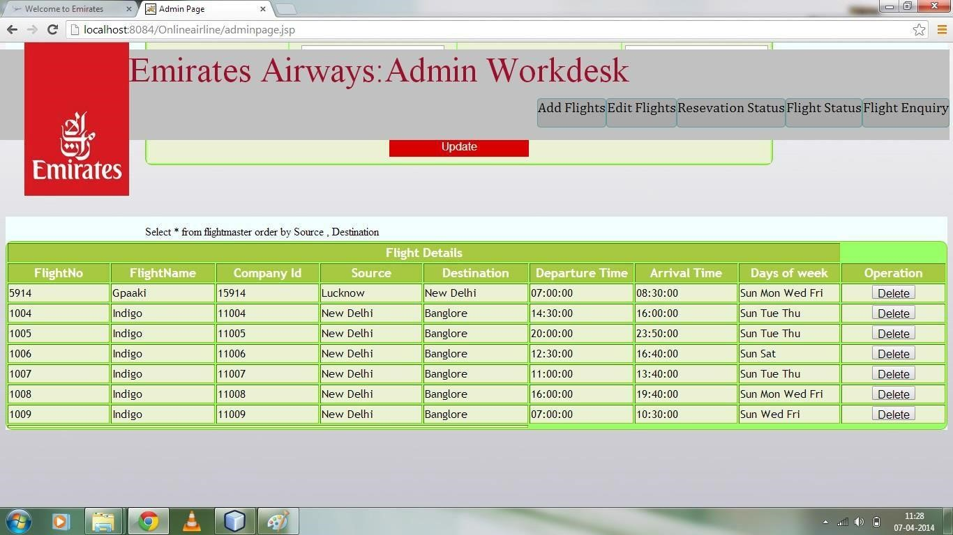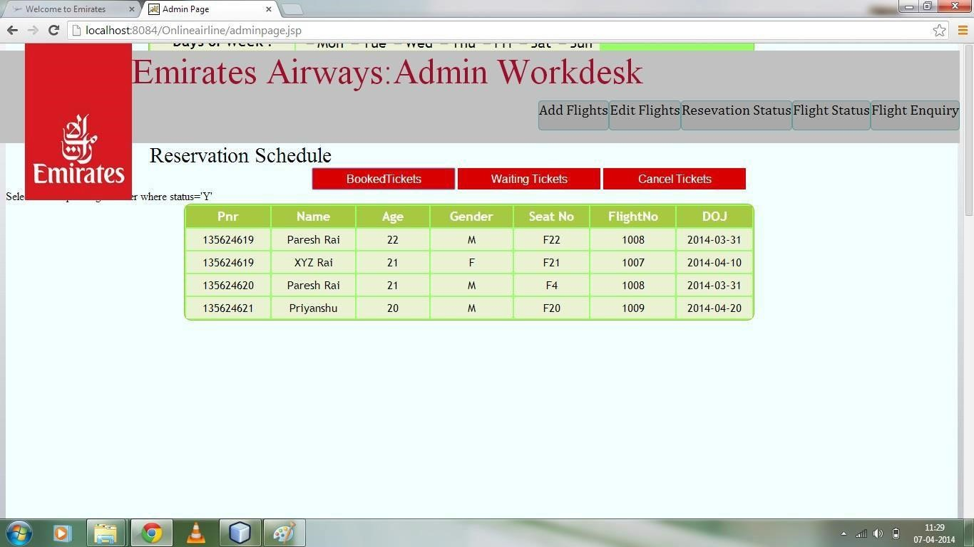

**Code snippet :**

##### 1.Index.jsp

<%@page contentType="text/html"%>

<%@page pageEncoding="UTF-8"%>

<%@tagliburi="/WEB-INF/mytld.tld" prefix="s" %><html>

<head>

<meta http-equiv="Content-Type" content="text/html;

charset=UTF-8" />

<link rel="shortcut icon" type="image/x-icon"

href="res/myairways-icon.ico">

<title>Emirates Airways : Book Tickets | Plan your Travel</title>

<link rel="stylesheet" href="res/styleSheet.css">

<script src="res/jquery.js"></script>

<script src="res/orsJavaScript.js"></script>

</head>

<body onload="getDateTime(),setdoj()">

<div id="header"> Airline Reservation System

</div>

<div id="datediv">

</div><br>

<div id="res" style="position:

absolute;left:300px;color:#3399ff;font-size: 18px;">

<% inti=0;

try{i=Integer.parseInt(request.getParameter("msgstring"));}catch(Exceptione){}

if(i==1)

{ out.println("User is successfully Registered .");

} if(i==2)

{ out.println("Please ! Register first .");

} if(i==3)

{ out.println("User is successfully Logged out .");

} if(i==4)

{ out.println("Incorrect UserId/Password"); }

%>

</div><br>

<div id="menu">

<div class="menuitem" id="divloginhere">Login Here</div>

<div class="menuitem" id="divflightstatus">Flight Status</div>

<div class="menuitem" id="divflightfare">Flight Fare</div>

<div class="menuitem" id="divflightschedule">Flight Schedule</div>

<div class="menuitem" id="divpnrstatus">PNR Status</div>

</div>

<div id="webpic">

<imgsrc="res/wall-pic1.1.jpg" id="pic1"></img>

<imgsrc="res/wall-pic2.1.jpg" id="pic2"></img>

<imgsrc="res/emirates.jpg" id="logoindex">

</div><br>

<div id="pnrstatus" class="hidediv">

<img class="btnimg" src="res\CloseButton.png"><br><br><fieldset><legend style="font-family:VelvendaCooler;font-

size:30px;">PNR Status</legend>

<form action="showticket.jsp">

<center>

<br><br>

Enter your PNR No. here :<input type="text"

class="text" name="pnr" placeholder="PNR No." maxlength="9"required><br><br>

<input type="submit" class="btn" value="Get PNR

Status"><br>

</center>

</form>

</fieldset>

</div>

<div id="flightschedule" class="hidediv">

<img class="btnimg" src="res\CloseButton.png"><br><br><fieldset><legend style="font-family:VelvendaCooler;font-

size:30px;">Get Flights</legend>

<form name="myform" action="searchflight.jsp"

method="post">

<center>

<select id="sourceplace" class="text">

<option value="--Select source place--">--Select

source place--</option>

<s:city></s:city>

</select><br>

<select id="destinationplace" class="text">

<option value="--Select destination place--">--

Select destination place--</option>

<s:city></s:city>

</select><br>

<input type="date" class="text" name="doj" id="doj"

min="" max="" required><br>

<input type="submit" class="btn" value="Get

Flights">

</center>

</form>

</fieldset>

</div>

<div id="flightfare" class="hidediv">

<img class="btnimg" src="res\CloseButton.png"><br><br><fieldset><legend style="font-family:VelvendaCooler;font-

size:30px;">Flight Fare</legend>

<form>

<center>

<br>

<select id="sourceplace" class="text">

<option value="--Select source place--">--

Select source place--</option>

<s:city></s:city>

</select><br>

<select id="destinationplace" class="text">

<option value="--Select destination place--

">--Select destination place--</option>

<s:city></s:city>

</select><br>

<input type="submit" class="btn" value="Get Fare"><br>

</center>

</form>

</fieldset>

</div>

<div id="flightstatus" class="hidediv">

<img class="btnimg" src="res\CloseButton.png"><br><br><fieldset><legend style="font-family:VelvendaCooler;font-

size:30px;">Flight Status</legend>

<form>

<center>

<br>

Enter Flight no. here :<input type="text"

class="text" name="flightno" placeholder="Flight No" maxlength="4"required><br><br>

<input type="submit" class="btn" value="Get Flight

Status"><br><br>

</center>

</form>

</fieldset>

</div>

<div id="loginhere" class="hidediv">

<imgsrc="res\CloseButton.png" class="btnimg" ><br><br>

<form name="myform" action="verification" method="post"><center>

<a href="registration.jsp"><span

id="registrationlink">Not yet registered ?</span></a><br>

Please Enter Your UserId and Password here :<br><br>

<input type="radio" name="radiologin"

value="customer" checked>Customer

&nbsp; &nbsp; &nbsp;

<input type="radio" name="radiologin"

value="admin">Admin<br>

<input type="text" class="text" name="userid"

placeholder="UserID" required><br>

<input type="password" class="text" name="pass"

placeholder="Password" required><br><br>

<input type="submit" class="btn">

</center>

</form>

</div>

<hr width="75%"></hr>

<div id="footer">

Created for Mini-Project in 3rd Year for session 2013-14 .

<br>

All Rights Reserved . @2014

</div>

</body>

</html>

##### 2.CustomerPage.jsp

<%@page import="java.util.Calendar"%>

<%@page pageEncoding="UTF-8"%>

<%@page import="java.sql.*"%>

<%@page import="daop.*"%>

<%@tagliburi="/WEB-INF/mytld.tld" prefix="s" %>

<!DOCTYPE html>

<%

HttpSessionsess = request.getSession(true);

String username = (String)sess.getAttribute("uname");String userid = (String)sess.getAttribute("uid");if(userid==null)

{ response.sendRedirect("index.jsp?msgstring=2");

} else

{

%>

<html>

<head>

<meta http-equiv="Content-Type" content="text/html;charset=UTF-8" />

<title>Welcome to Emirates</title>

<link rel="shortcut icon" type="image/x-icon"href="res/myairways-icon.ico">

<link rel="stylesheet" href="res/styleSheet.css">

<script src="res/jquery.js"></script>

<script src="res/orsJavaScript.js"></script>

</head>

<body onload="setdoj()">

<% response.setContentType("text/html; charset=UTF-8");response.setCharacterEncoding("UTF-8");

%>

<div id="welcomecustomer">

<imgsrc="res/emirates.jpg" id="logocustomer" align="top" >

<p style="margin-left:300px;">Emirates Airways : Customer

Workdesk</p>

<div style="position: relative ;top:-10px;margin-bottom: -

50px;">

<span id="username" style="font-size:

30px;color:navy;margin-left: 300px;">Welcome : <%=username%></span>

<a href="logout"><imgsrc="res/logout-button.png"

id="logout" title="Logout"></a>

</span><br><br>

</div>

<span id="result" style="position:reltive;font-

size:25px;color:#D80000;font-variant: normal;margin-left: 350px;">

<% inti=0;

try{i=Integer.parseInt(request.getParameter("msgstring"));}catch(Exception e){}

|  |  |  |
| --- | --- | --- |
|  |  | if(i==0)  { |
| account ."); |  | out.println("Book your tickets and manage your  } if(i==1)  { |
|  |  | out.println("Your Profile has been updated |

successfully ."); } if(i==2)

{

out.println("Your Profile can't be updated . Please Try again .");

} if(i==3) {

out.println("Your Password has been changed successfully ."); } if(i==4) {

out.println("Your Password can't be changed.

Please Try again .");

}

%>

</span><br>

</div>

<div id="webpic" style="margin: 0px 160px 310px 160px;">

<imgsrc="res/cutomer-wall.jpg" id="pic1"

style="width: 1030px;" align="center">

</div>

<div id="customercontent" style="height: inherit;"><div id="option"><ul>

<li class="listoption" id="custstatus">Check PNR

Status</li>

<li class="listoption" id="custbook">Book

Ticket</li>

<li class="listoption" id="custcancel">Cancel

Ticket</li>

<li class="listoption" id="custedit">Edit

Account</li>

<li class="listoption" id="custeditp">Change

Password</li>

<li class="listoption" id="custguide">Reservation Guide</li>

</ul>

</div>

<div id="maincontent">

<div id="main" class="custcontent" style="display:

block;text-align: justify;">

<%

DBServicedb=new DBService();

ResultSet r1=db.selectData("select distinct

flightno,doj from ticketmaster where userid='"+userid+"' ");

while(r1.next())

{

ResultSet r2=db.selectData("select

departuretime,arrivaltime from flightreschedule whereflightno="+r1.getString(1)+" and doj='"+r1.getString(2)+"'"); if(r2.next())

{

ResultSet r3=db.selectData("select

source,destination from flightmaster whereflightno="+r1.getString(1));

r3.next();

out.println("<marquee scrollamount=10

scrolldelay=200 onmouseover=\"return stop()\"onmouseout=\"returnstart()\"><h4><font size=4 color=navy>Flightno "+r1.getString(1)+"will depart from "+r3.getString(1)+" at "+r2.getString(1)+" and arriveat "+r3.getString(2)+" at "+r2.getString(2)+" on

"+r1.getString(2)+"</h4></font></marquee><br><br>");

}

}

%>

Feel an excellent travel experience with EmiratesAirways on an exclusive affordable price .

Emirates - Trying To make your journey safer ,

cheaper , better .

So , book your tickets now for all around the

world and have a great traveling experience with Emirates Airways .<br></br>Feel an excellent travel experience with EmiratesAirways on an exclusive affordable price .

</div>

<div id="status" class="custcontent">

<br>

<%

ResultSet rs1=db.selectData("select

pnr,flightno,doj from ticketmaster where userid='"+userid+"' order bydoj"); if(rs1.next())

{

%>

Click on the PNR No. :<br><br><table id="tablepnrstatus">

<tr>

<th>PNR No.</th>

<th>Flight No.</th>

<th>From</th>

<th>To</th>

<th>DOJ</th>

</tr>

<% while(true)

{

String fid=rs1.getString(2); ResultSet rs2=db.selectData("select

source,destination from flightmaster where flightno="+fid); rs2.next();

String pnr1=rs1.getString(1);

String s1="showticket.jsp?pnr="+pnr1;

%>

<tr>

<td id="pnr"><a href=<%=s1%>><%=pnr1%></td>

<td><%=fid%></td>

<td><%=rs2.getString(1)%></td>

<td><%=rs2.getString(2)%></td>

<td><%=rs1.getString(3)%></td>

</tr>

<% if(!rs1.next()) {

break;

}

}

%>

</table>

<% } else

{ out.println("<br><br><br><br> There is no

ticket booked from your account <br><br><br><br>");

}

%>

</div>

<div id="book" class="custcontent">

<fieldset><legend style="font-family:VelvendaCooler;font-size:30px;">Get Flights</legend>

<form action="bookflight.jsp" method="post"

onsubmit="return bookflight(this)">

<center><br><table>

<tr>

<td>Source place :</td>

<td>

<select id="sourceplace"

class="text" name="sourceplace" onchange="return checksource(this)">

<option value="--Select source

place--" selected="selected">--Select source place--</option>

<s:city></s:city>

</select>

</td>

</tr>

<tr>

<td>Destination place :</td>

<td>

<select id="destinationplace"

class="text" name="destinationplace" onchange="returncheckdestination(this)">

<option value="--Select

destination place--" selected="selected">--Select destination place--

</option>

<s:city></s:city>

</select>

</td>

</tr><tr>

<td>Travel Date :</td><td><input type="date"

class="text" name="traveldate" id="doj" min="" max="" required></td>

</tr><tr>

<td>Adult :<input type="number"

class="vstext" name="adult" value="0" min="1" max="5"></td>

<td>Child :<input type="number"

class="vstext" name="child" value="0" min="0" max="3"></td>

</tr>

<trrowspan="2">

<thcolspan="2"><input type="submit"

class="btn" value="Get Flights">

</th>

</tr>

</table>

</center>

</form>

</fieldset>

</div>

<div id="guide" class="custcontent">

<%@include file="guide.html"%><br></br>

</div>

</div>

</div>

<br>

<div id="footer">

Created for Mini-Project in 3rd Year for session 2013-14 .

<br>

All Rights Reserved . @2013

</div>

</body>

</html>

<%}%>

**3.Book.java :**

package customermodule;import daop.*; import java.io.*;import java.sql.*; import java.util.Calendar;import javax.servlet.*;import javax.servlet.http.*;

public class book extends HttpServlet {

@Override protected void service(HttpServletRequestreq, HttpServletResponseresp)

throws ServletException, IOException

{ int j=0,len=0,y=1;

PrintWriter out=resp.getWriter();

HttpSession session=req.getSession(false); String userid=(String)session.getAttribute("uid");out.println(userid);

String flightno=req.getParameter("flightno");

intclassid=Integer.parseInt(req.getParameter("classid"));

String doj=req.getParameter("doj");

String adultname[]=req.getParameterValues("name");

String adultage[]=req.getParameterValues("age");

String adultgender[]=req.getParameterValues("gender");

String childname[]=req.getParameterValues("childname");

String fare=req.getParameter("fare"); Calendar cal=Calendar.getInstance();

String dob=cal.get(Calendar.YEAR)+"-"+(cal.get(Calendar.MONTH)+1)+"-

"+cal.get(Calendar.DATE); intaano=adultname.length;intacno=childname.length;intaanoa=adultage.length;intaanog=adultgender.length;

String cname="",cseat="",cid="",an="",a="",g="";String[] cseats; for(String p : adultname)

{ if(p.equals(""))aano--;

}

for(String p : adultage)

{ if(p.equals(""))aanoa--;

}

for(String p : adultgender)

{ if(p.equals("--Select--"))aanog--;

} int m=aanog<aanoa ?aanog : aanoa ;aano=aano< m ? aano : m; inttfare=aano*Integer.parseInt(fare);for(String p : childname)

{ if(p.equals(""))acno--;

} for(j=0;j<acno;j++)

{

String n=childname[j];cname=cname+n+":";

} if(classid==1)cid="F";

else if(classid==2)cid="B";

else if(classid==3)cid="E";

long pnr=0;

DBServicedb=new DBService();int start=0;

ResultSet rs1=db.selectData("select avail,cseat fromflightavailability where flightno="+flightno+" and classid="+classid+" anddoj='"+doj+"'");

ResultSet rs2=db.selectData("select pnr from pnr");try

{ rs1.next(); rs2.next();cseat=rs1.getString(2);

start=Integer.parseInt(rs1.getString(1));pnr=Long.parseLong(rs2.getString(1));pnr++;

} catch(Exception e)

{ }

cseats=cseat.split("@");len=cseats.length;if(len!=0) len=len-1; if(start>=aano)

{ db.updateData("insert into ticketmaster

values("+pnr+",'"+userid+"',"+flightno+","+classid+",'"+doj+"',"+aano+","+ac no+","+tfare+",'"+cname+"','Y','"+dob+"',0)");

} else if(start>0)

{ if(aano<=(start+len))

{ db.updateData("insert into ticketmaster

values("+pnr+",'"+userid+"',"+flightno+","+classid+",'"+doj+"',"+aano+","+ac no+","+tfare+",'"+cname+"','Y','"+dob+"',0)");

} else

{ db.updateData("insert into ticketmaster

values("+pnr+",'"+userid+"',"+flightno+","+classid+",'"+doj+"',"+aano+","+ac no+","+tfare+",'"+cname+"','W','"+dob+"',0)");

}

} else

{ if(aano<= (len - -start))

{ db.updateData("insert into ticketmaster

values("+pnr+",'"+userid+"',"+flightno+","+classid+",'"+doj+"',"+aano+","+ac no+","+tfare+",'"+cname+"','Y','"+dob+"',0)");

} else

{ db.updateData("insert into ticketmaster

values("+pnr+",'"+userid+"',"+flightno+","+classid+",'"+doj+"',"+aano+","+ac no+","+tfare+",'"+cname+"','W','"+dob+"',0)");

} }

for(inti=0;i<aano;i++)

{ an=adultname[i];a=adultage[i];g=adultgender[i];if(start>0)

{ int n=0;n=start;n=n-len;if(n>0)

{

String seat=cid+n;start--;

db.updateData("insert into passengermaster

values("+pnr+",'"+an+"',"+a+",'"+g+"','"+seat+"','Y','"+dob+"')");

} else

{

String seat=cseats[y];y++; len--; start--;

db.updateData("insert into passengermaster

values("+pnr+",'"+an+"',"+a+",'"+g+"','"+seat+"','Y','"+dob+"')"); }

}

else{

start--;

String seat="W"+ -start;db.updateData("insert into passengermaster

values("+pnr+",'"+an+"',"+a+",'"+g+"','"+seat+"','W','"+dob+"')"); } }

len=cseats.length;cseat="@";

for(inti=y;i<len;i++)

{ cseat=cseat+cseats[i]+"@";

} db.updateData("update flightavailability set avail="+start+" ,cseat='"+cseat+"' where flightno="+flightno+" and classid="+classid+" anddoj='"+doj+"'"); db.updateData("update pnr set pnr='"+pnr+"'");resp.sendRedirect("showticket.jsp?pnr="+pnr); }

}

**4.Cancel.java :**

package customermodule;import java.io.*;import javax.servlet.*; import javax.servlet.http.*;import java.sql.*; import java.util.*; public class cancel extends HttpServlet {

@Override

protected void service(HttpServletRequestreq, HttpServletResponseresp)

throws

ServletException, IOException

{

PrintWriter out=resp.getWriter();

String pnr=req.getParameter("pnr");

String fid="";

String cls="";String doj="";intrfare=0;int fare=0; String cseat="";

String cid="";

Calendar cal=Calendar.getInstance();

String dom=cal.get(Calendar.YEAR)+"-"+(cal.get(Calendar.MONTH)+1)+"-

"+cal.get(Calendar.DATE); int no=0,tno=0;String[] seat;

seat=req.getParameterValues("seat");intlen=seat.length;out.println(len);

daop.DBServicedb=new daop.DBService();

ResultSet rs1=db.selectData("select flightno,classid,doj,rfare fromticketmaster where pnr="+pnr);

try

{ rs1.next();fid=rs1.getString(1);cls=rs1.getString(2);doj=rs1.getString(3);

rfare=Integer.parseInt(rs1.getString(4));

ResultSet rs5=db.selectData("select fare from flightfaremap

where flightno="+fid+" and classid="+cls);

rs5.next();fare=Integer.parseInt(rs5.getString(1));

}

catch(Exception ex)

{

}

ResultSet rs2=db.selectData("select avail ,cseat fromflightavailability where flightno="+fid+" and classid="+cls+" anddoj='"+doj+"'");

ResultSet rs4=db.selectData("select * from passengermaster wherestatus='W' and pnrin(select pnr from ticketmaster where flightno="+fid+"and classid="+cls+" and doj='"+doj+"' and status='W') order by seatno");

try

{ rs2.next(); no=rs2.getInt(1);cseat=rs2.getString(2);no=no+len; tno=no; for(String x: seat)

{ db.updateData("update passengermaster set status='C' ,

seatno='---' ,dom='"+dom+"' where pnr="+pnr+" and seatno='"+x+"'");

int p=(int)fare/2;rfare=rfare+p;

if(x.startsWith("F") || x.startsWith("B") ||

x.startsWith("E")) { if(rs4.next())

{

String mpnr=rs4.getString(1);String mseat=rs4.getString(5); db.updateData("update passengermaster set status='Y'

, seatno='"+x+"' where pnr="+mpnr+" and seatno='"+mseat+"'"); no--; } else

{ cseat=cseat+x+"@";

}

}

}

db.updateData("update ticketmaster set rfare="+rfare+" where pnr="+pnr);

while(rs4.next())

{

String mpnr=rs4.getString(1);String mseat=rs4.getString(5);

intino=Integer.parseInt(mseat.substring(1));ino=ino-len; cid="W"+ino;

db.updateData("update passengermaster set seatno='"+cid+"'

where seatno='"+mseat+"' and pnr="+mpnr);

}

ResultSet rs5=db.selectData("select pnr from ticketmaster where

flightno="+fid+" and classid="+cls+" and doj='"+doj+"'");

while(rs5.next())

{

String mpnr=rs5.getString(1);

ResultSet rs3=db.selectData("select status from

passengermaster where pnr="+mpnr); boolean b=true;

|  |  |  |  |
| --- | --- | --- | --- |
|  | while(rs3.next())  { if(rs3.getString(1).equals("W"))b=false;  } if(b==true) db.updateData("update ticketmaster set status='Y' where  pnr="+mpnr);  } } catch(Exception e)  { }out.println(cseat);  db.updateData("update flightavailability set cseat='"+cseat+"' ,  avail="+tno+" where flightno="+fid+" and classid="+cls+" anddoj='"+doj+"'"); resp.sendRedirect("showticket.jsp?pnr="+pnr); }  } | | |
| **S.N** |  | **BIBLOGRAPHY**  **BOOK NAME** | **AUTHOR** |
| 1. |  | HEAD FIRST SERVLETS AND JSP | BASHAM SIERRA AND BATES |
| 2. |  | JAVA COMPLETE REFERENCE | HERBERT SCHILDT |
| 3. |  | CORE JAVA VOLUME 1 AND 2 | G. CORNELL & C.S. HORSTMANN |
| 4. |  | JAVA BLACK BOOK (Servlets , JSP)  33 | SANTOSH KUMAR |